Migrating quotas

Introduction 1

Brief refresher on type of quota 1

Brief refresher on the quota data objects 2

Quota order numbers 2

Quota order number origins 3

Quota definitions 3

Quota associations 3

Quota suspension periods 3

Quota blocking periods 3

# Introduction

Quotas are complex data objects that need multiple steps to be undertaken to remove the EU quotas build them back up again for the UK's independent trade policy.

There are multiple steps involved – the concept for WTO / ATQ quotas and those involved in Trade Agreements is similar but sufficiently different to point out the slight variances.

The overall process is as follows – necessary to perform in this order, so as to not break any of the Taric business rules.

* Step 1 – Terminate all EU quota definitions
* Step 2 – Terminate all EU quota measures
* Step 3 – Reload (together) UK quota measures and definitions (as well as quota associations)

# Brief refresher on type of quota

Quotas can be sliced in two ways:

* by purpose / legislative instrument
* by administration method

### Types of quota by legislative instrument

There are broadly speaking 3 types of quota that we need to be concerned with:

* **WTO Quota** – typically (though not exclusively) assigned to the whole world (Erga Omnes), these are lodged with the WTO as part of our overall Tariff submission. The exception is the beef quota, where we have individual quotas with individual countries, as well as a rump quota for Erga Omnes
* **Autonomous Tariff Quota (ATQ)** – these are not submitted to the WTO: we decide on these autonomously (hence the name) without submission as part of our schedule. These are always used (a little bit like reliefs and suspensions) for goods that are going to be imported and then materially transformed into something else.
* **Preferential Quota** – managed as part of a Trade Agreement, these are always ranged against an individual country or trading bloc.

In actual fact, for the purposes of data load and migration, the difference between ATQ and WTO quota is negligible, and we deal with these as if they were one type.

### Types of quota by administration method

There are 2 ways of administering quotas:

* **First Come First Served** – an initial balance is set up, then once the quota goes live, traders draw down on that balance until it is exhausted. The majority of quotas are set up in this way. An important distinction for us here is that all data that is set up in TAP by DIT is sent to HMRC's CDS system
* **Licensed quotas** – traders wanting to take advantage of licensed quotas need to apply directly to the Rural Payments Agency (RPA) to get a piece of the pie for licensed quotas. Though there is an initial balance for licensed quotas, we do not manage it in TAP. The only data that is sent to CDS is the measures associated with the quota, not the quota itself or its definitions.

# Brief refresher on the quota data objects

The following objects are used in managing quotas in the Tariff database:

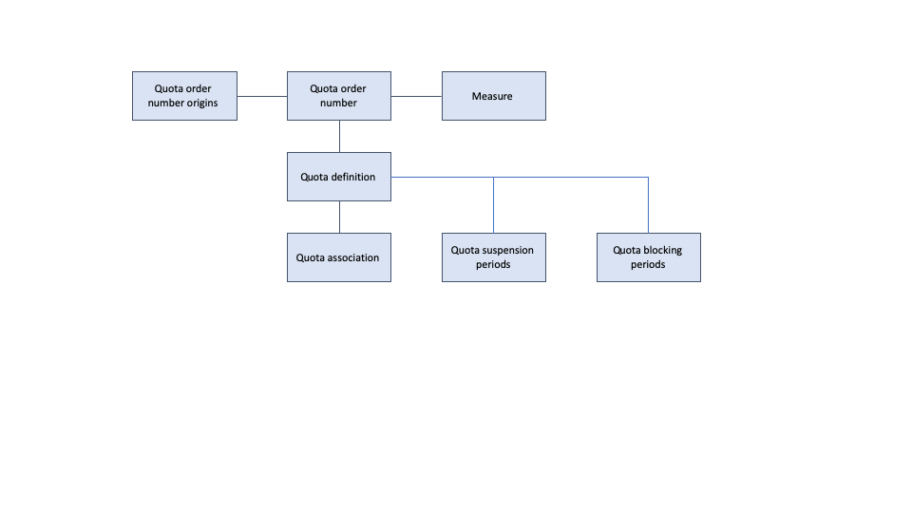

## Quota order numbers

The core defining object with regard to quotas, the quota order number table is a very simple table which maintains the 6-digit order number and the validity start and end dates for that quota. The 6-digit order number always begins with "09". If the quota is a licensed quota, then the third digit is always a "4". If not a licensed quota, then the third digit can be any number.

For licensed quotas, we do not send any values in the quota order number table to CDS. TAP and CDS should never contain any quotas whose order numbers commence "094", though such quotas are referenced in the measures table.

## Quota order number origins

All quota order numbers are assigned to one or more countries or trading blocs – this is mirrored in both the quota order number's relationship to quota order numbers, and in the related measure's reference to a single geographical_area_id in the measures table.

## Quota definitions

This is where most of the work is done with quotas. A quota definition represents a period of time (for example a year) for which a quota runs and for which there is an opening balance available.

We do not manage quota definitions for licensed quotas.

## Quota associations

For some quotas, there is an association between a parent and child quota – when a trader decrements the balance of a child quota, this also decrements the balance of the parent. This is especially prevalent with the WTO beef quotas, but also in the infamous Moroccan tomato quota, which is expected to be discontinued.

## Quota suspension periods

If there is a need to temporarily suspend a quota (e.g. there is no value in running it as the MFN is zero and the administrative costs of doing so make it worthless), then a record is created here.

## Quota blocking periods

If there is a need to temporarily block traders from applying to use a quota, then a record is created here.

# Process steps in detail

## Terminating quota definitions

The purpose of this step is to ensure that the data that is pertinent to the UK's independent trade policy on 1st November is 100% brand new and not intermingled with any data that is hung over from the EU's trade policy.

The way to do this is to end-date all definitions in the entire database that would otherwise have straddled the 1st November deadline and to delete completely and definitions that would have started after November 1st. In deleting such future definitions, future associations and blocking / suspension periods are also deleted.

There is a single script to perform these tasks, located in the "**migrate_measures_and_quotas**" folder. It is run by calling the following command line script:

terminate_quota_definitions.py

This script created a file entitled terminate_quota_definitions.xml in the **/xml_out** subfolder.

## Terminating quota measures